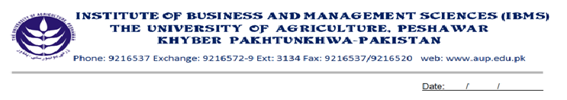
Program: BS(CS)-V
Course Title: Theory of Automata and Formal Languages
Course Code: CS-503
Session: 2010-2013
Credit Hours: 03
Course Week: 16
Total Credit Hours: 48

.Course Objective
Purpose: It is a very important subject related to applied mathematics. In computer science it has a very broad application, in a sense that every application in the background uses algorithms designed by this subject. In other words we can say that the computer really grown up due to the waste application of this subject. Most of the companies and universities keep secret the research held in this field. The purpose of these outlines is to make a student able to understand the processing of computer at the design level and to bring him to the research level.

Week-1
-Introduction
-Used and Application
-Application in Compiler Design
-Application in Word Processing

Week-2
-Formal and Informal languages
-Alphabets, strings, Word
-Valid and In-valid alphabets, Length of a string

Week-3
-Defining a language
-Descriptive Definition of a language
-Equal, Even-Even, Integer, Even, {A ^{n} B ^{n} }, { A ^{n} B ^{n} C ^{n}}
-Factorial, SQUARE, PRIME, PALINDROME etc.

Week-4
-Kleen Star Closure, Plus operator (+)
-Recursive Definition of a language
-Integer, Even, Factorial, Palindrome, {A ^{n} B ^{n}}

Week-5
-Regular languages
-Defining language by R.E

Week-6
-Defining Languages by FA
-NFA
-DFA

Week-7
-Transition Table Representation of NFA
-Memory required to recognize a Language

Week-8.9
-Conversion of NFA to DFA
-By Subset Conversion Method
-By E-closure Method

Week-10
-Introduction to Palindrome
- -Even palindrome
- -Odd palindrome

Week-11
-Finite automata with outputs
-Moore machine
-Incrementing Machine, Complementing Machine

Week-12
-Mealy machine
-Mealy machine in terms of Electric Circuit

Week-13
-Context free grammar
-Symbols, Examples

Week 14
-Definition of PDA
-Conversion of CFG to PDA

Week-15
-Introduction to Turing Machine.
Week-16
-Revision, Presentation and Viva

Total Marks: 100
Recommended Books:
- Introduction to computer theory by Danial I.A. cohen
- Introduction to Automata theory, Languages and Computation by John E. Hopcroft.
- Introduction to computer theory by Papademethru

